**Motor Imagery Classification**

**Kirtan Amitkumar Jha and Naren Vishwanath Kalburgi**

**Abstract**:

The main task of the motor imagery classification is to analyze the electroencephalography (EEG) data from a brain-computer interfaces (BCI) system. The noise recorded by the BCI system may corrupt the data obtained and will reduce the classification accuracy. In this project, a motor imagery classification based on different classifiers is performed. The results reveal that motor imagery is subject dependent and the proposed classification can improve the performance of a BCI system and that SVM and LDA classifiers gave better accuracy among the models tested. Classification was done on 4 classes which are imagery of left hand, right hand, both feet and tongue

**Introduction:**

A brain computer interface (BCI) is a communication system which carries the brain's messages to a computer. The frontier between humans and computers is bridged using brain computer interface. In order for the computer to monitor our brain signals it needs to record the brain activity. Cells in our brain produces a very small electrical signal known as brain waves and to record the electrical activity of the brain we use electroencephalography (EEG).

Electroencephalography is an electrophysiological method to record electrical activity of the brain. The device consists of electrodes which is placed on the scalp, this measures the voltage fluctuation which is resulted from the ionic current within the neurons of the brain. EEG measures different types of brain waves and they are  alpha, beta, theta, delta and gamma. The BCI collects and analyzes the electroencephalography (EEG) signals from the subject and translates into command to the operating device.

Motor Imagery(MI) is a state in which an individual mentally simulates a given task. In most of the research of Motor Imagery it includes movement of left and right hand, tongue and feet movements. In our project, a non-invasive BCI based on EEG signak analysis for MI is presented. In this paper, we introduce feature extraction. Besides, different classifiers are tested and accuracy of them is calculated.

**Dataset Description**:

Though data was not collected by us but still we would like to give some information on the dataset. Dataset was collected from open source website of BCI competition IV - Dataset 2-A It has 9 subjects and data was recorded in GDF format (General data format). Task was to be performed between 3 to 6 seconds and after that there was a resting period of some seconds. 25 electrodes were placed on the subject’s scalp according to Internationally approved 10-20 system. Out of which 22 were EEG channels and 3 ECOG. There were total of 288 trials for each of the subjects.The signals were sampled at 250 Hz and a fourth order butterworth filter was used (4-40Hz)

**Signal Preprocessing**:

Wavelet packet decomposition

Applied band pass filter(7-30Hz)

Split data into train and test data

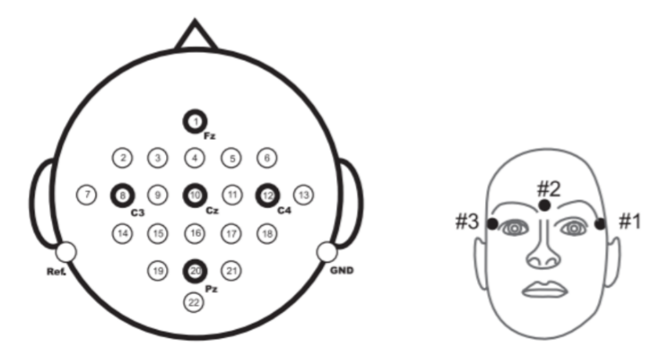

Figure Electrodes position

Before working on the signals it is important that e studied the EEG signals and observe what exactly is going on. We plotted raw signals and also tried Independent component analysis on the signals. Below are the figures for more reference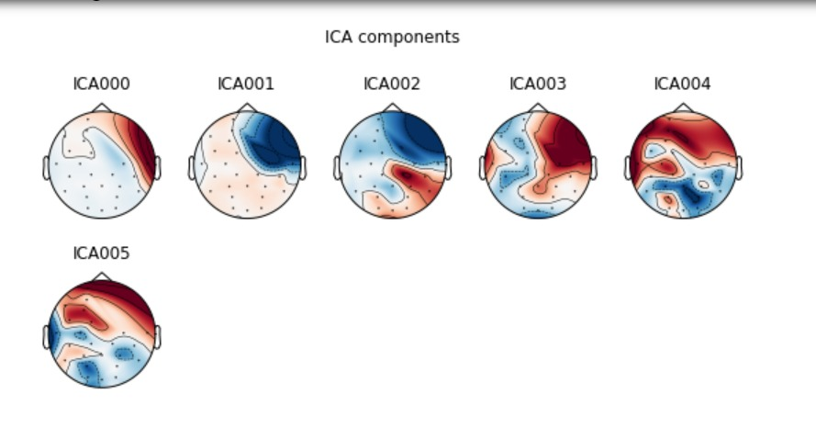

Figure ICA analysis

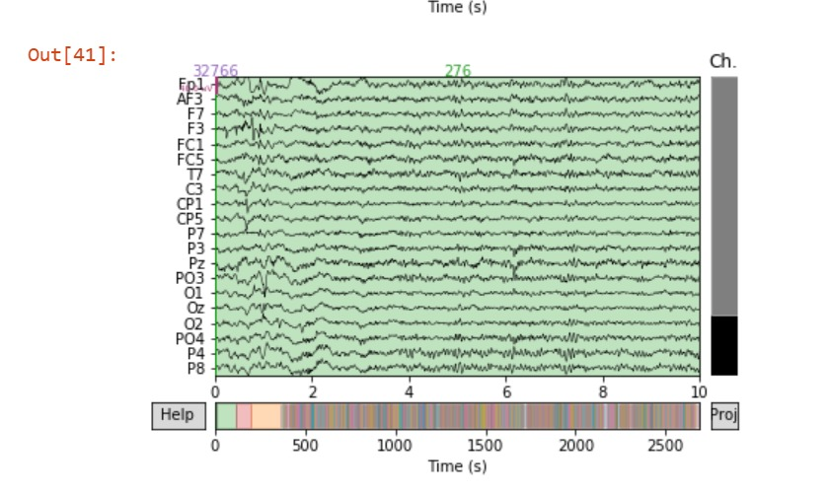

Figure Raw signal observation 22 channels

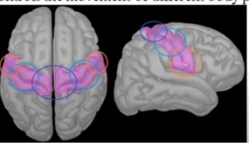

Figure Brain part observation

For selecting the channels we need to know in which region of brain particular task for motor imagery is happening:

Region 1 (region in orange) : This is responsible for face and mouth movements

Region 2(region in pale blue): This is responsible for hand movements

Region 3(region in blue, between both hemisphere): This is responsible for le movements

**Signal processing:**

After preprocessing, the epochs of every considered channel were analyzed with different methods to extract the feature characteristics corresponding to each event.

1.Band pass filtering

As the imagery task is performed in the brain between 8-14 Hz of alpha waves and 15-30 Hz of beta waves, frequencies before 8 and after 30 hz should be removed as it will be considered as noise, so a bandpass filter of 7,30Hz was passed on each subject’s signals

2.Wavelet packet decomposition

Originally known as Optimal Subband Tree Structuring (SB-TS) also called Wavelet Packet Decomposition (WPD) (sometimes known as just Wavelet Packets or Subband Tree) is a wavelet transform where the discrete-time (sampled) signal is passed through more filters than the discrete wavelet transform (DWT).

For n levels of decomposition the WPD produces 2n different sets of coefficients (or nodes) as opposed to (n + 1) sets for the DWT. However, due to the downsampling process the overall number of coefficients is still the same and there is no redundancy

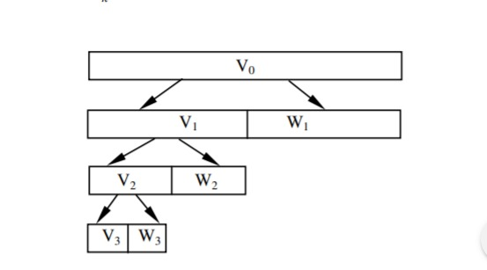

Figure WPD explanation

We also took the epoch averages for each classes :

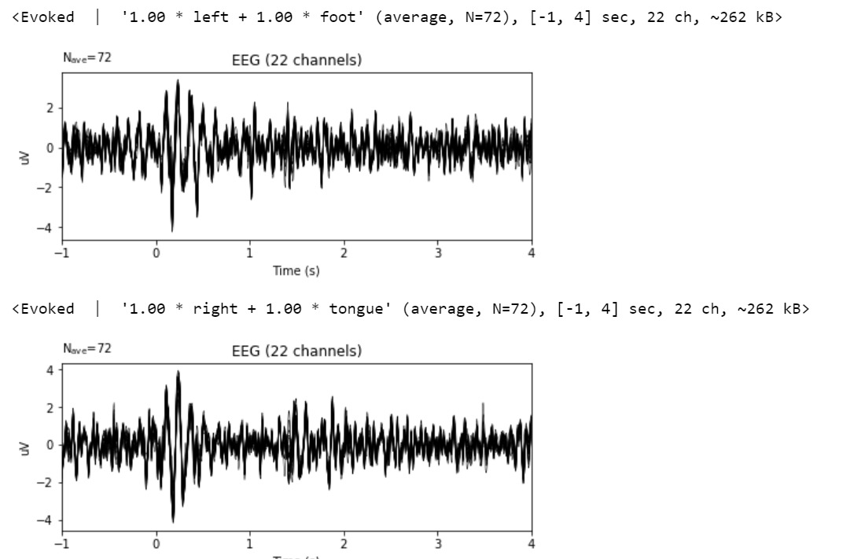

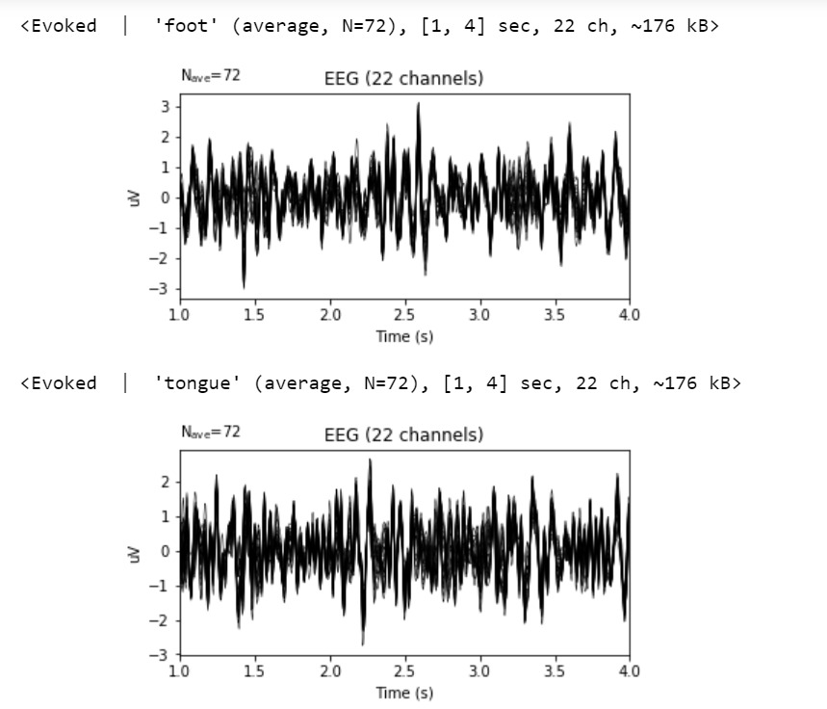

Figure Epoch averages over time

.

**Signal post processing**:

Once the characteristics have been extracted from each electrode and epoch, the classifiers classified the data based on the event.

Accuracy was calculated as shown in the below table:

**Classifiers Used:**

Linear Discriminant Analysis(LDA)

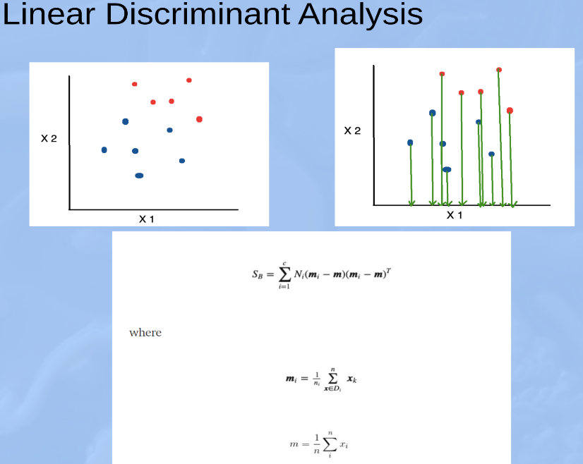

k-nearest neighbors(KNN)

Multi-layer Perceptron (MLP)

Support Vector Machnes(SVM)

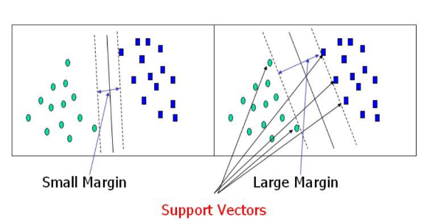

Common Spaitial Pattern(CSP) with 10 K-cross fold validation

Accuracy Table:

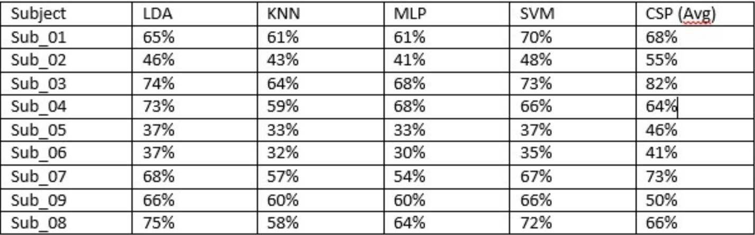

Figure Comparision of accuracies

Results:

The results reveal that the proposed classification models can improve the performance of the multi class BCI system. Among all the classifiers used, SVM and LDA are the most optimum classifiers for 4- class motor imagery classification problem. Description of each classifiers is not added as it will digress the main topic of the project.

Discussion and Conclusion:

This paper compared 22 channels, two types of features, and five classifiers and found the optimal combination for motor imagery BCIs with single-channel EEGs. An open access database, BCI competition IV dataset 2a, was used for assessment.We also tried Common spatial filtering methods with 10 K-cross fold validation technique which can be seen in the codes we submitted but forgot to mention in the presentation also the results were not so promising. Deep learning is the term which is used most now a days. We also tried designing convolutional neural networks for classification purposes. But this work is still in progress as designing optimal network will give more accurate results.

Contribution and challenges:

The main challenge we faced during this whole project was to learn the EEG signals and acquiring the dataset. Also designing the classifiers was a huge task as it is hit and trial with different parameters. The best results are taken out and presented here. Kirtan and Naren both designed and did the code for every subjects and the work was divided equally among both of them. Firstly the code written only classified on 144 trials rather than 288 trials, later on it was debugged and finally classification was done on all 288 trials. Codes are provided with this report which are well documented and commented.

One of the problems faced while decoding EEG signals is that classifiers do not generalize well. This means that one cannot train classifiers on one subject and test on another. The eventual goal of this research is to experiment with the idea of subject independent feature decoding.

**Special Note: Codes submitted are for single subject only. It was the same for every subjects file except the parameters which were changed for getting better accuracies

References:

<http://www.bbci.de/competition/iv/desc_2a.pdf>

<https://en.wikipedia.org/wiki/Wavelet_packet_decomposition>

<https://mne.tools/stable/index.html>